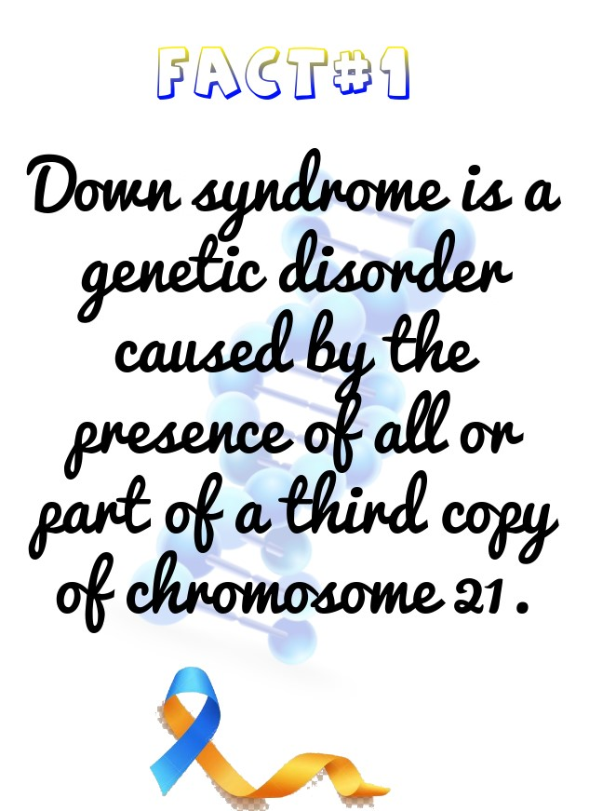

**Day#1**: Down syndrome (DS) is a genetic disorder caused by the presence of all or part of a third copy of chromosome 21. It is typically associated with physical growth delays, characteristic facial features, and mild to moderate intellectual disability. It’s not a disease, people with DS don’t “suffer” from it.

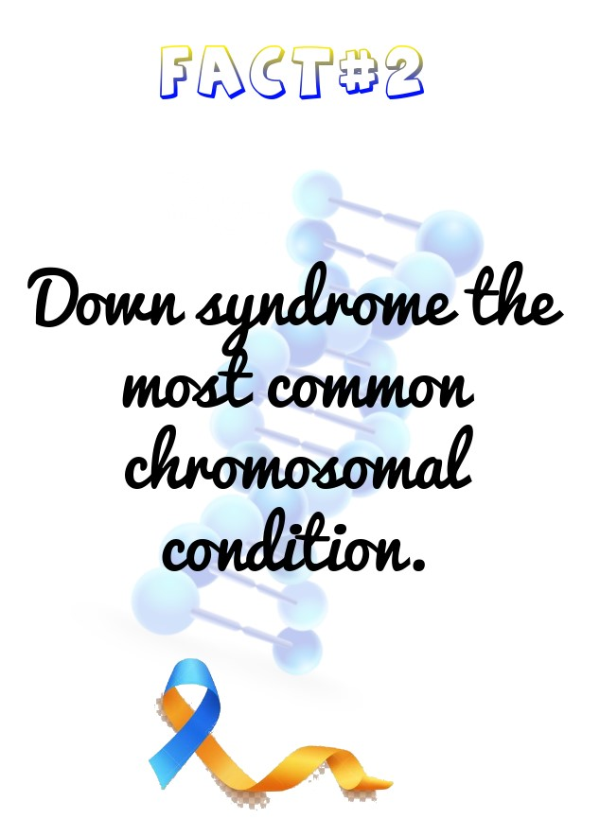

**Day#2**: India being one of the highest populated nations, there is greater incidence of Down Syndrome and it occurs in approximately 1 out of 830 live births. Down syndrome the most common chromosomal condition.

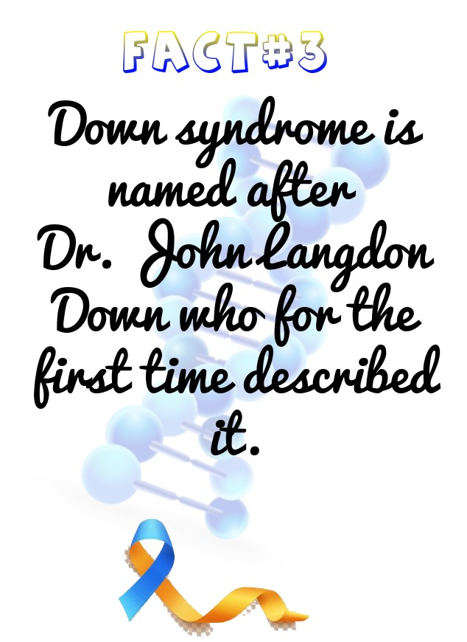

**Day#3**: The word 'Down' in Down syndrome is not used as an adjective. It rather is a proper noun because the Syndrome is named after Dr. John Langdon Down who for the first time described it in 1862.

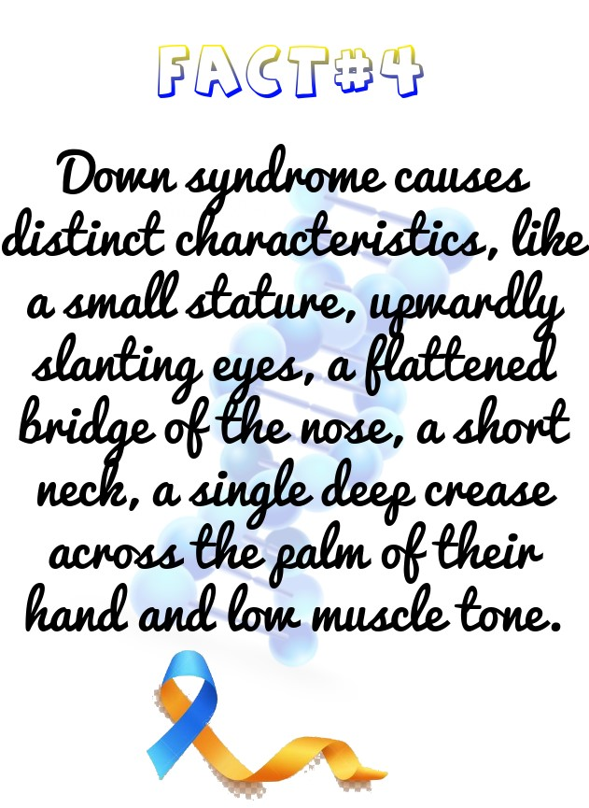

**Day#4**: Symptoms of Down syndrome aren’t the same for each person. The genetic disorder causes many distinct characteristics, like a small stature, upwardly slanting eyes, a flattened bridge of the nose, a short neck, a single deep crease across the palm of their hand and low muscle tone. However, each person will have different degrees of the characteristics, and some of the features may not appear at all.

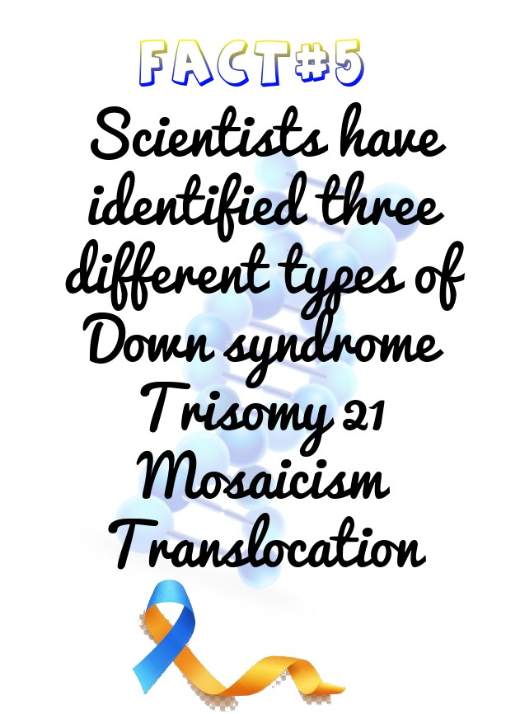

**Day#5**: Scientists have identified three different types of Down syndrome

**Trisomy 21**: This occurs when there’s an error in the cell division called ‘nondisjunction’ which results in three chromosomes in an embryo instead of two.

**Mosaicism**: This occurs when there’s a mix of two types of cells, some containing 46 chromosomes and some with 47. The ones with 47 contain the extra 21 chromosome.

**Translocation**: This type is relatively less common. In this scenario, the number of chromosomes remains 46 but an additional or partial copy of chromosome attaches to another chromosome.

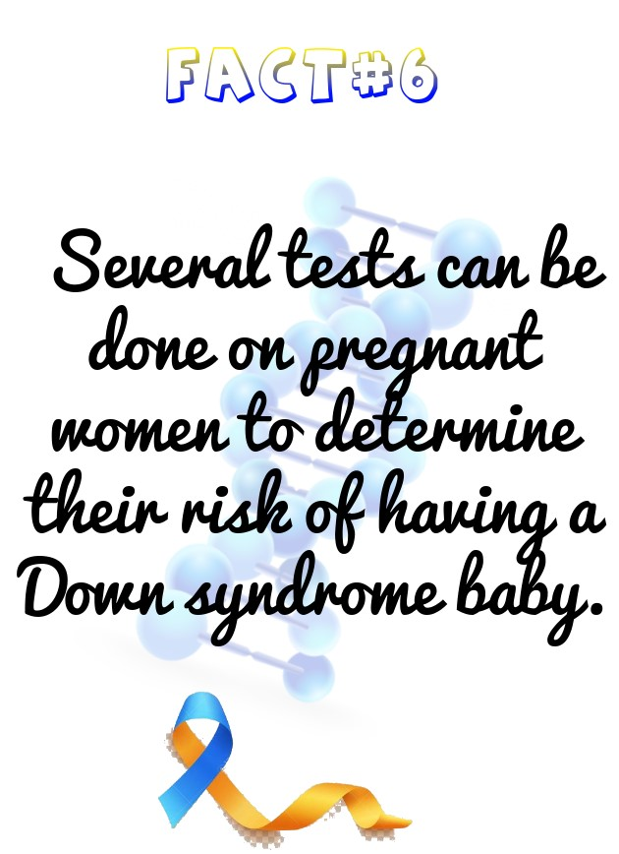

**Day#6**: Most children with Down syndrome are born to women younger than 35 years old simply because younger women have more children. However, the likelihood of having a child with Down syndrome increases with the age of the mother, especially after age 35. Several tests can be done on pregnant women to determine their risk of having a Down syndrome baby. A positive screening test can be followed up by an amniocentesis.

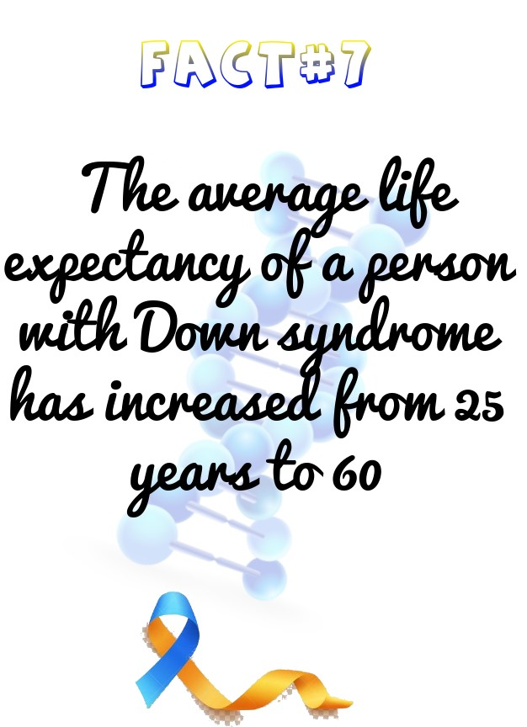

**Day#7**: In 1983, the average life expectancy of a person with Down syndrome was a mere 25-years-old. Today, it’s 60.

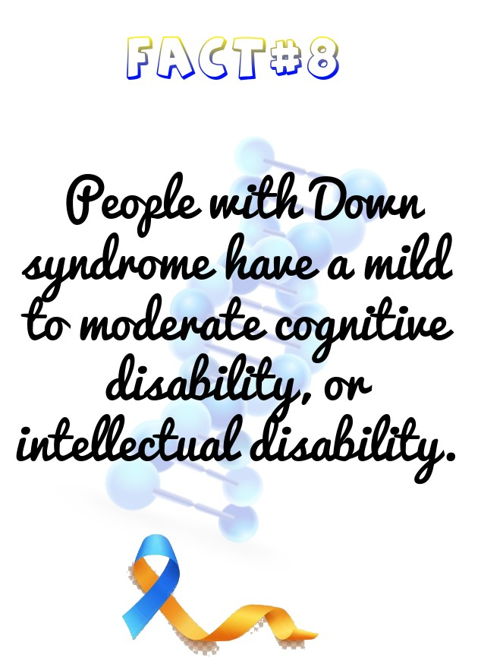

**Day#8**: Most people with Down syndrome have a mild to moderate cognitive disability, or intellectual disability. This is not indicative of the many strengths and talents that each individual possesses. Children with Down syndrome go through the same stages of development as typical children but it takes a little longer to achieve those milestones. Be considerate of the extra time it might take a person who has a disability to get things done or said.

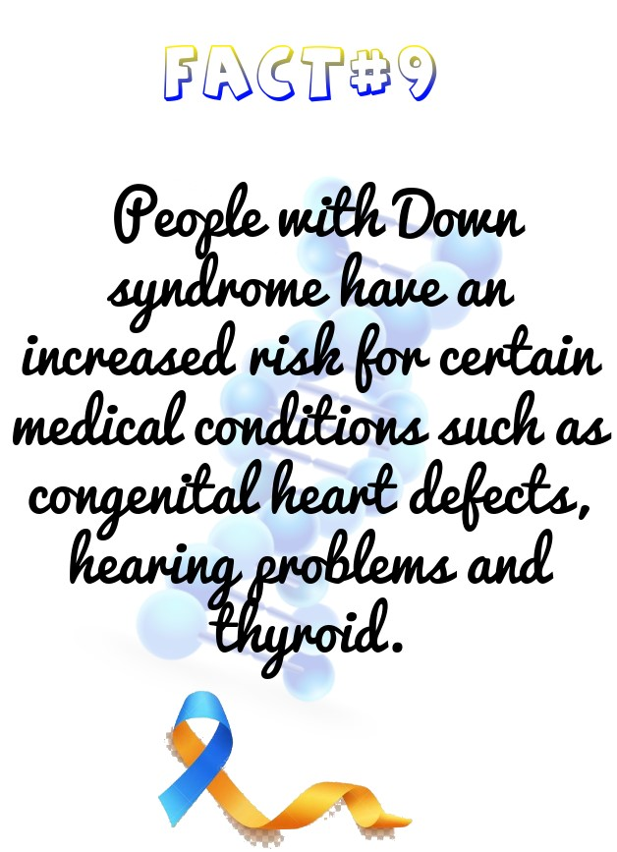

**Day#9**: People with Down syndrome have an increased risk for certain medical conditions such as congenital heart defects, respiratory and hearing problems, Alzheimer’s disease, childhood leukemia and thyroid conditions. Many of these conditions are now treatable, so most people with Down syndrome lead healthy lives

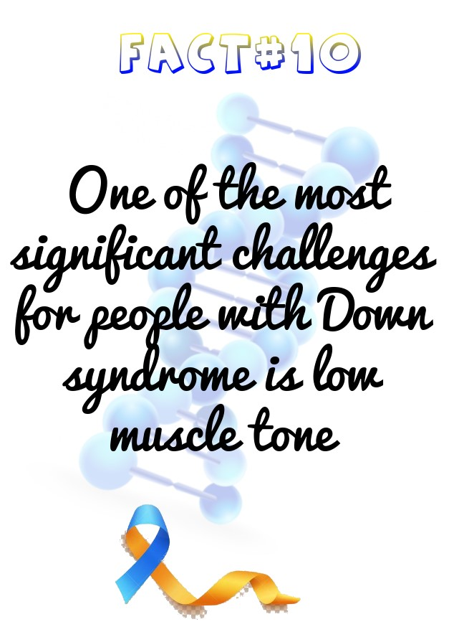

**Day#10**: One of the most significant challenges for people with Down syndrome is low muscle tone. Low muscle tone affects speech, gross motor skills, and fine motor skills. Speech, physical, and occupational therapy help.

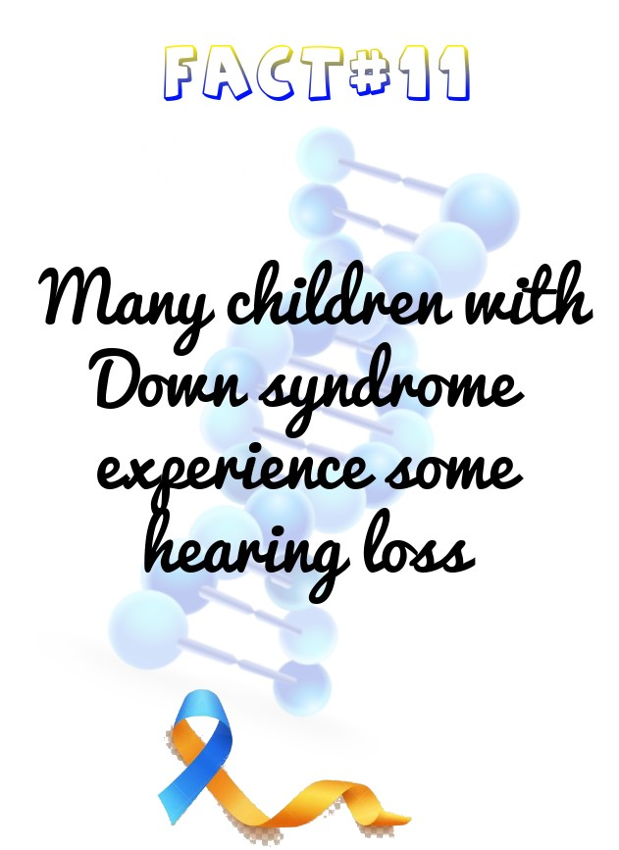

**Day#11**: Many children with Down syndrome experience some hearing loss, especially in the early years. Up to 20% may have a sensori-neural loss, caused by developmental defects in the ear and auditory nerves. Many have smaller sinuses and ear canals which result in frequent upper respiratory tract infections: this leads to over 50% suffering from periodic conductive hearing loss due to glue ear.

Since hearing problems will affect speech and language development, it is particularly important to check children’s hearing carefully and regularly. Also clarity in hearing can fluctuate daily and it is important to check that inconsistencies in response are due to hearing loss rather than lack of understanding or poor attitude.

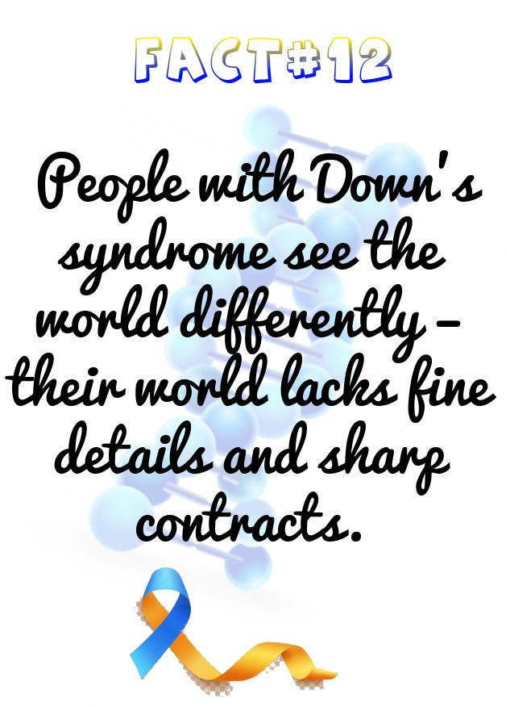

**Day#12**: People with Down’s syndrome see the world differently – their world lacks fine details and sharp contracts. In order to compensate for the poorer visual acuity we can make the world around them BIG and bold.

Big and Bold printed materials and images will help – people with Down’s syndrome are visual learners so to help them succeed make sure they can see things. It is very important to take their poorer visual acuity into account in all learning environments.

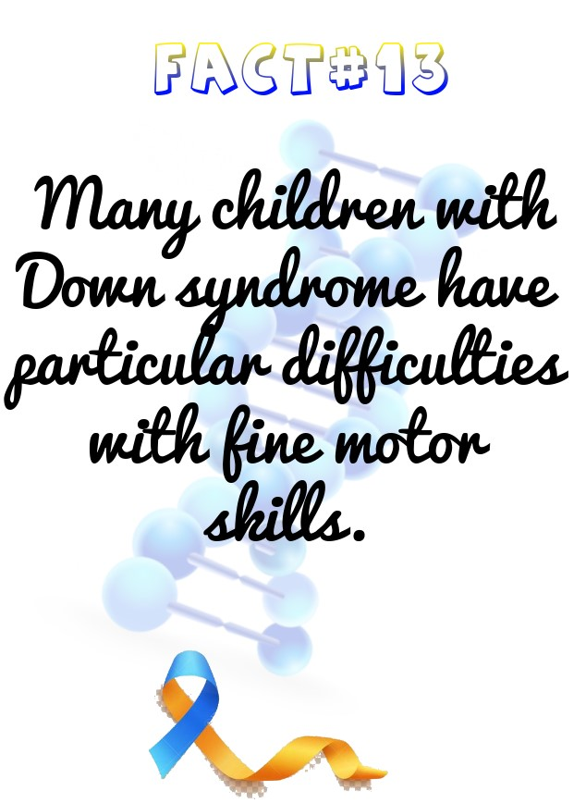

**Day#13**: Many children with Down syndrome have particular difficulties with fine motor skills. In addition to hypotonia, the fingers are often short and the thumb set low down.This, together with motor processing and sensory integration difficulties, affects their level of dexterity, manipulation and hand-eye coordination. These in turn affect their ability to hold and control a pen or pencil, use scissors or manipulate small objects.

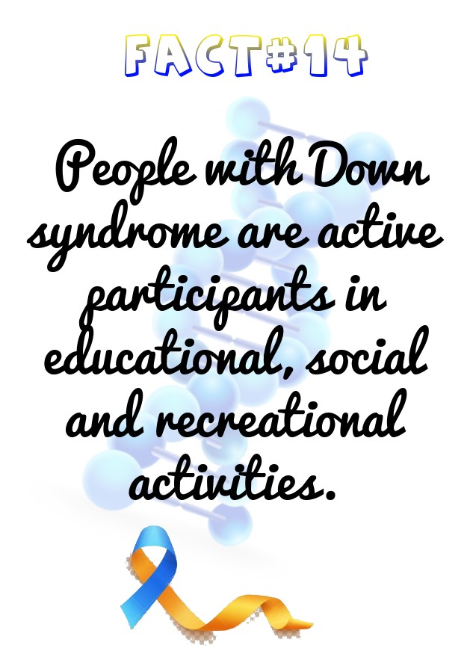

**Day#14**: People with Down syndrome are active participants in educational, social and recreational activities. They are included in the typical education system and take part in sports, music, art programs and any other activities in the community. They are valued members of their families and communities, and make meaningful contributions to society.

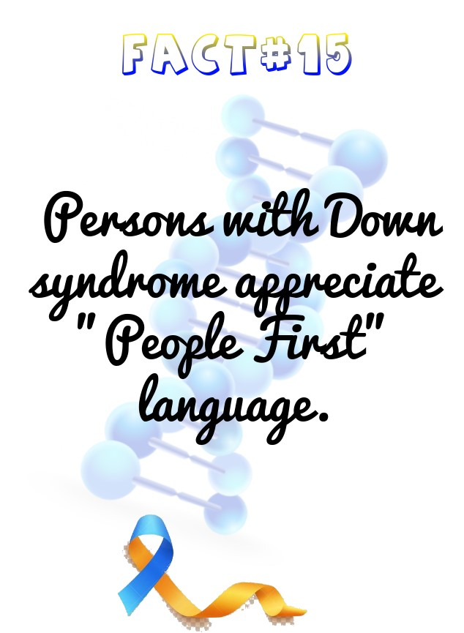

**Day#15**: Persons with Down syndrome appreciate "People First" language. We say kid with Down syndrome and not Down syndrome kid. Down syndrome is just a diagnosis not identity of a person

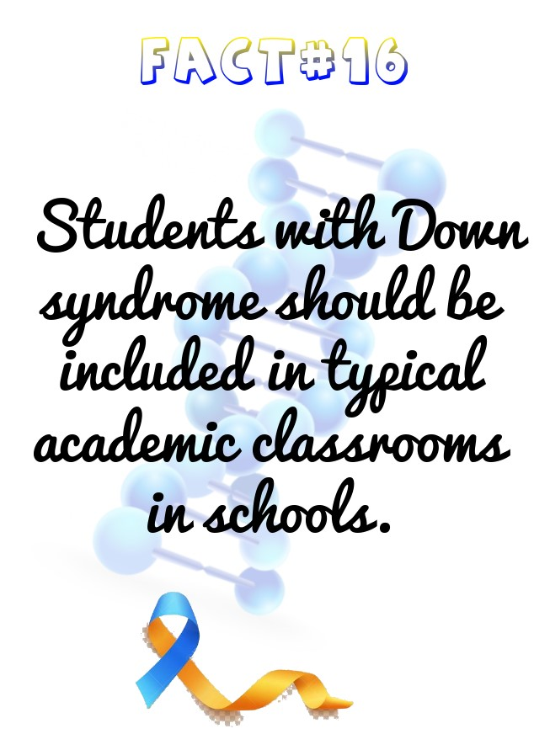

**Day#16**: Students with Down syndrome should be included in typical academic classrooms in schools. The current trend in education is for full inclusion in social and educational settings. Sometimes students with Down syndrome are included in specific courses, while in other situations students are fully included in the typical classroom for all subjects. Increasingly, individuals with Down syndrome graduate from high school with diplomas, and participate in postsecondary academic and college programs. They typically do best in an inclusive learning environment, and typical kids do best when they learn about diversity, kindness, and friendship at an early age. Inclusive classrooms teach and benefit all kids.

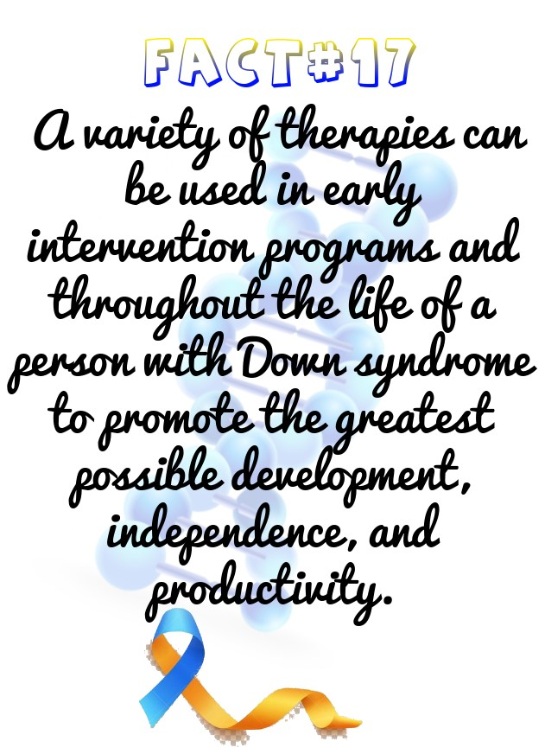

**Day#17**: A variety of therapies can be used in early intervention programs and throughout a person's life to promote the greatest possible development, independence, and productivity. Some of these therapies are physiotherapy, speech –language therapy, occupational therapy and emotional and behavioural therapy.

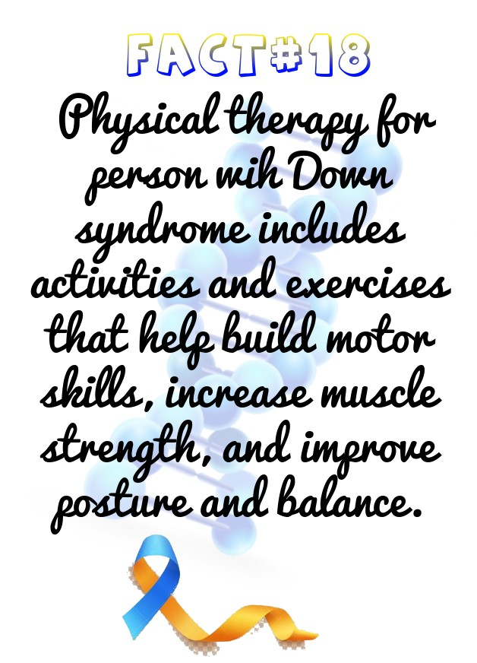

**Day#18**: Physical therapy includes activities and exercises that help build motor skills, increase muscle strength, and improve posture and balance.

a. Physical therapy is important, especially early in a child's life, because physical abilities lay the foundation for other skills. The ability to turn over, crawl, and reach helps infants learn about the world around them and how to interact with it.

b. A physical therapist also can help a child with Down syndrome compensate for physical challenges, such as low muscle tone, in ways that avoid long-term problems. For example, a physical therapist might help a child establish an efficient walking pattern, rather than one that might lead to foot pain

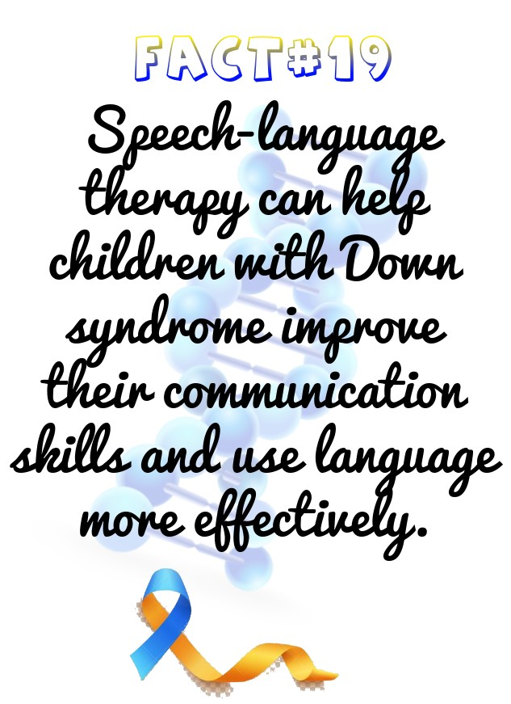

**Day#19:** Speech-language therapy can help children with Down syndrome improve their communication skills and use language more effectively.

a. Children with Down syndrome often learn to speak later than their peers. A speech-language therapist can help them develop the early skills necessary for communication, such as imitating sounds. The therapist also may help an infant breastfeed because breastfeeding can strengthen muscles that are used for speech.5

b. In many cases, children with Down syndrome understand language and want to communicate before they can speak. A speech-language therapist can help a child use alternate means of communication, such as sign language and pictures, until he or she learns to speak.7

c. Learning to communicate is an ongoing process, so a person with Down syndrome also may benefit from speech and language therapy in school as well as later in life. The therapist may help with conversation skills, pronunciation skills, understanding what is read (called comprehension), and learning and remembering words.

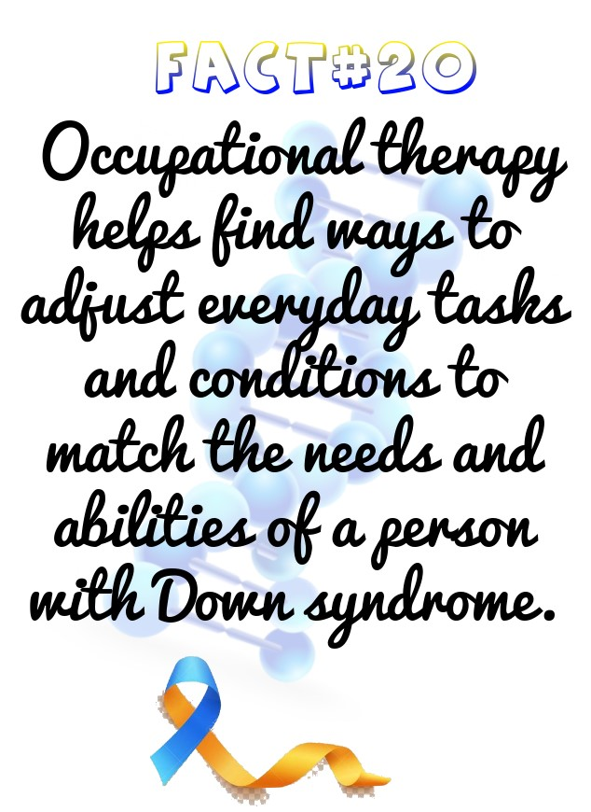

**Day#20**: Occupational therapy helps find ways to adjust everyday tasks and conditions to match a person's needs and abilities.

a. This type of therapy teaches self-care skills5 such as eating, getting dressed, writing, and using a computer.

b. An occupational therapist might offer special tools that can help improve everyday functioning, such as a pencil that is easier to grip.

c. At the high school level, an occupational therapist could help teenagers identify jobs, careers, or skills that match their interests and strengths.

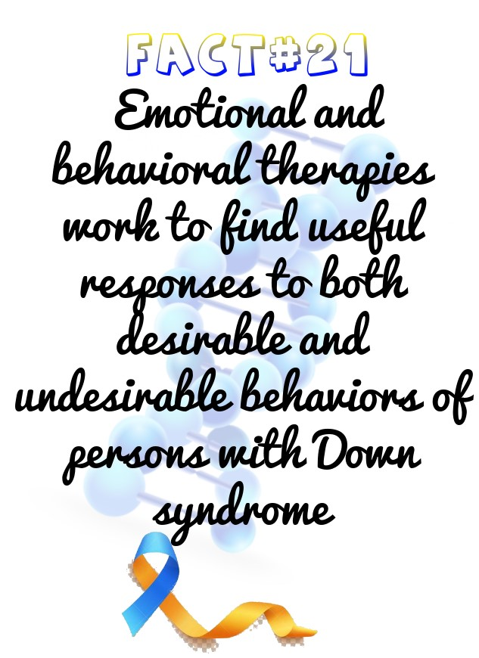

**Day#21**: Emotional and behavioral therapies work to find useful responses to both desirable and undesirable behaviors. Children with Down syndrome may become frustrated because of difficulty communicating, may develop compulsive behaviors, and may have Attention Deficit Hyperactivity Disorder and other mental health issues. These types of therapists try to understand why a child is acting out, create ways and strategies for avoiding or preventing these situations from occurring, and teach better or more positive ways to respond to situations.

a. A psychologist, counselor, or other mental health professional can help a child deal with emotions and build coping and interpersonal skills.

b. The changes in hormone levels that adolescents experience during puberty can cause them to become more aggressive. Behavioral therapists can help teenagers recognize their intense emotions and teach them healthy ways to reach a feeling of calmness.

c. Parents may also benefit from guidance on how to help a child with Down syndrome manage day-to-day challenges and reach his or her full potential.

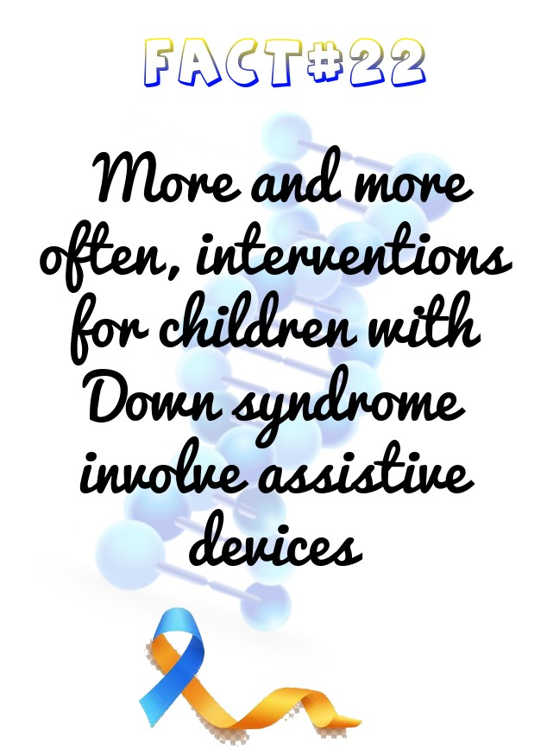

**Day#22**: More and more often, interventions for children with Down syndrome involve assistive devices—any type of material, equipment, tool, or technology that enhances learning or makes tasks easier to complete. Examples include amplification devices for hearing problems, bands that help with movement, special pencils to make writing easier, touch screen computers, and computers with large-letter keyboards.

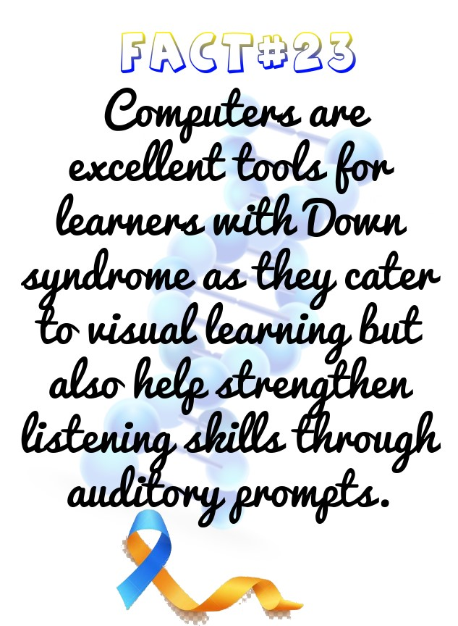

**Day#23**: Computers are excellent tools for learners with Down syndrome as they cater to visual learning but also help strengthen listening skills through auditory prompts. Programs may contain plenty of built-in feedback, encouragement, rewards, and praise, which is delivered when goals are met.

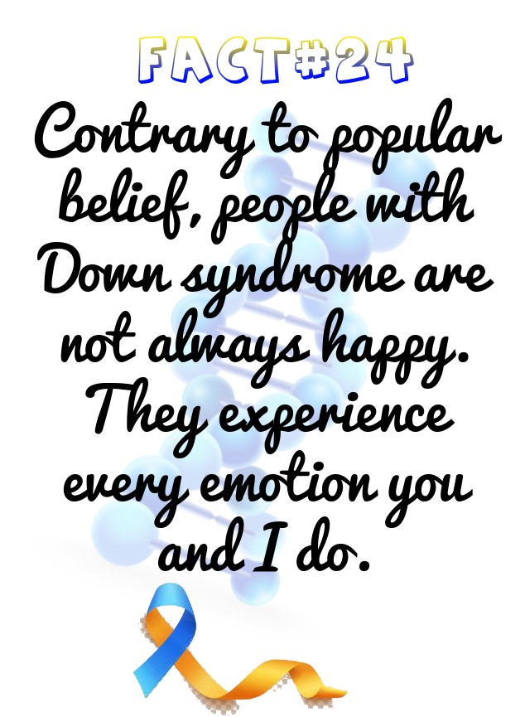

**Day#24**: Contrary to popular belief, people with Down syndrome are not always happy. They experience every emotion you and I do. They experience the full range of emotions. They respond to positive expressions of friendship and are hurt and upset by inconsiderate behaviour

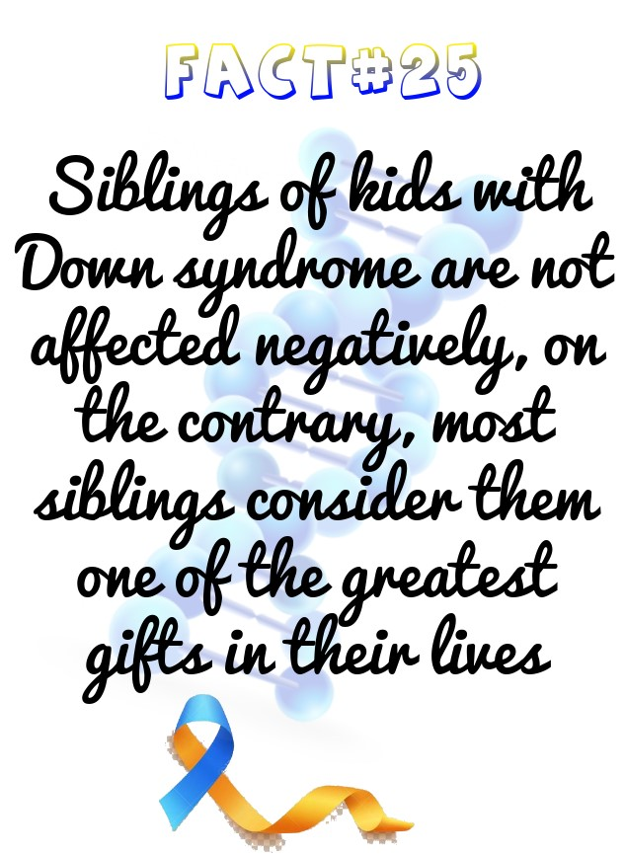.

**Day#25**: Siblings of kids with Down syndrome are not affected negatively, on the contrary, most siblings report their relationship with a brother or sister with Down syndrome is one of the greatest gifts in their lives. Studies show that 99% of adults with Down syndrome are happy with their lives and only 5% of parents feel embarrassed by their child with Down syndrome.

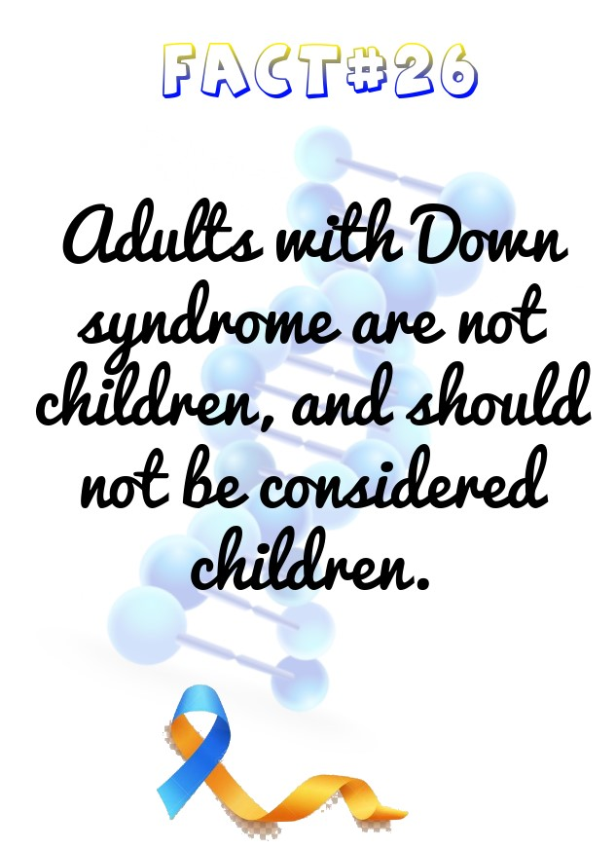

**Day#26**: Adults with Down syndrome are not children, and should not be considered children. They enjoy activities and companionship with other adults, and have similar needs and feelings as their typical peers. They socialize and have meaningful friendships. Some choose to date, maintain ongoing relationships and marry.

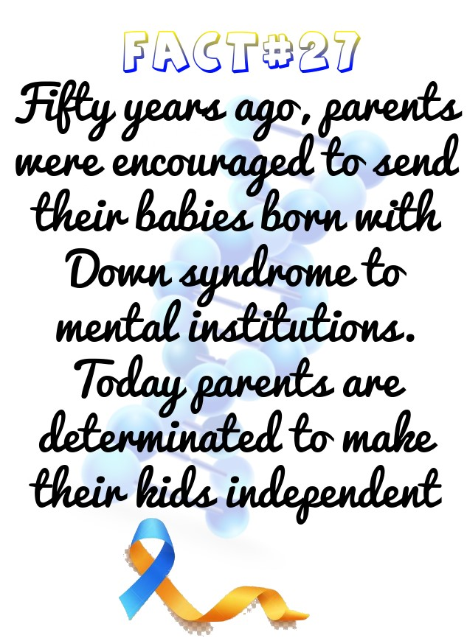

**Day#27**: Fifty years ago, parents were encouraged to send their babies born with Down syndrome to mental institutions. That was not too long ago. What you see now is the hard work and determination of parents (like Rekha Maa) willing to fight the battle for their children, and for the many that have followed

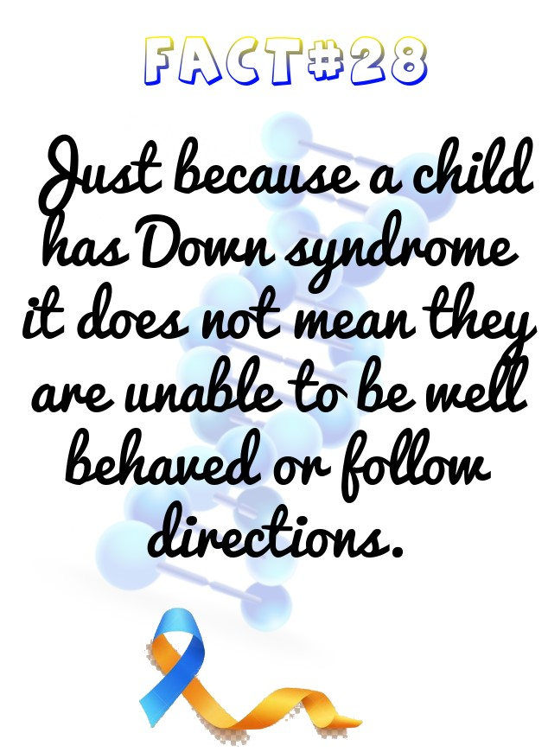

**Day#28**: You will get what you expect! Just because a child has Down syndrome it does not mean they are unable to be well behaved or follow directions. Kids with Down syndrome are smart, it takes them a few minutes to recognize expectations, and you will be manipulated to the best of their ability. Businesses employ adults with Down syndrome for a variety of positions – in banks, corporations, hotels, hospitals, nursing homes, offices and restaurants. They work in the music and entertainment industry, in clerical positions, childcare, the sports field and the computer industry, to name a few. Like anybody else, people with Down syndrome want to have a job where their work will be valued.

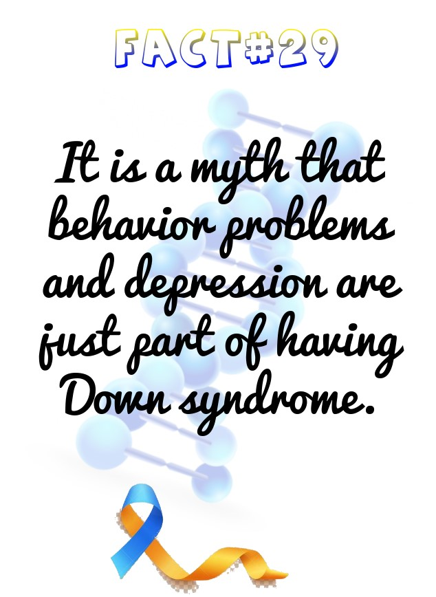

**Day#29**: It is a myth that behavior problems and depression are just part of having Down syndrome. However, the fact is that often, medical or mental health problems go untreated due to the assumption that it is typical of this genetic condition. Complete examinations by appropriate health care professionals should always be pursued.

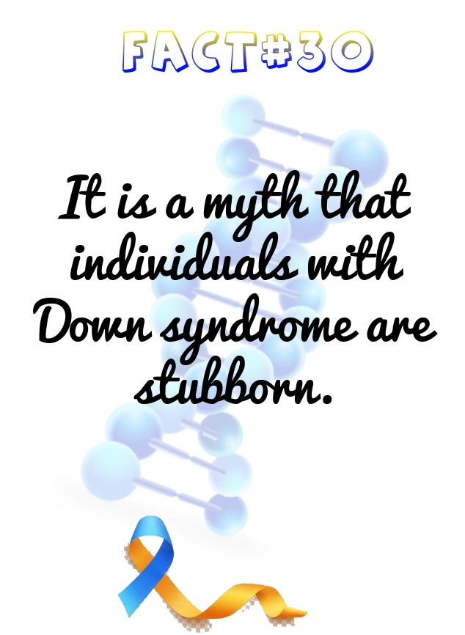

**Day#30**: It is a myth that individuals with Down syndrome are stubborn. The fact is that the individuals with Down syndrome may not be able to tell you how she/he feels. This can lead to the false perception that they are “stubborn.” Behaviour is communication. Consider all of the circumstances.

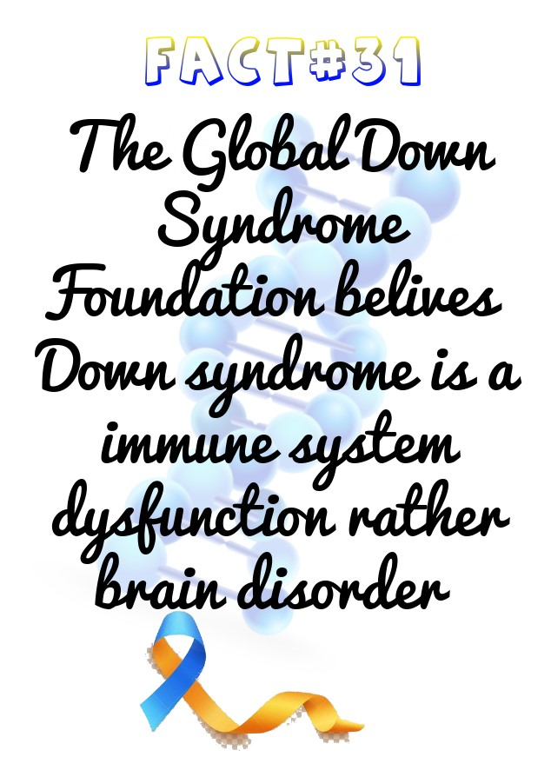

**Day#31**: A recent study published in Scientific Reports, and publicized by the Global Down Syndrome Foundation, changed the perception of Down syndrome as a brain disorder and categorized it as immune system dysfunction instead. According to the study, intellectual disability related to Down syndrome may be the result of a hyperactive immune system. Research on Down syndrome is making great strides in identifying the genes on chromosome 21 that cause the characteristics of Down syndrome. Scientists now feel strongly that it will be possible to improve, correct or prevent many of the problems associated with Down syndrome in the future."